
MBARARA UNIVERSITY OF SCIENCE AND TECHNOLOGY
FACULTY OF HEALTH SCIENCES
DEPARTMENT OF BIOCHEMISTRY

COURSE: BIOINFORMATICS AND COMPUTER ORIENTATION
SUPERVISOR: MR. EZINGA RICHARD

STUDENT NAME: ATWAU PIUS
REG NO. 2025/MMSc/038/PS

TITLE: COMPARATIVE WHOLE-GENOME ANALYSIS OF MYCOBACTERIUM TUBERCULOSIS ISOLATES: VARIANT ANNOTATION, LINEAGE CLASSIFICATION, AND PHYLOGENETIC INFERENCE

Tasks
- Annotate the variants and explain their biological impact.
- Conduct a lineage profile and give a sound report for this.
- Use a phylogenetic tree to infer evolutionary relatedness.

Installation of required tools

For variant annotation,
Goal
To predict the functional effects of mutations.
Tools
- SnpEff
- TB-Profiler.

For lineage profiling
Goal:
To classify samples into M. tuberculosis lineages.

- TB-Profiler

Phylogenetic Reconstruction
Goal
To visualize the evolutionary relationships between the isolates
- Iqtree
- Figtree

Methods
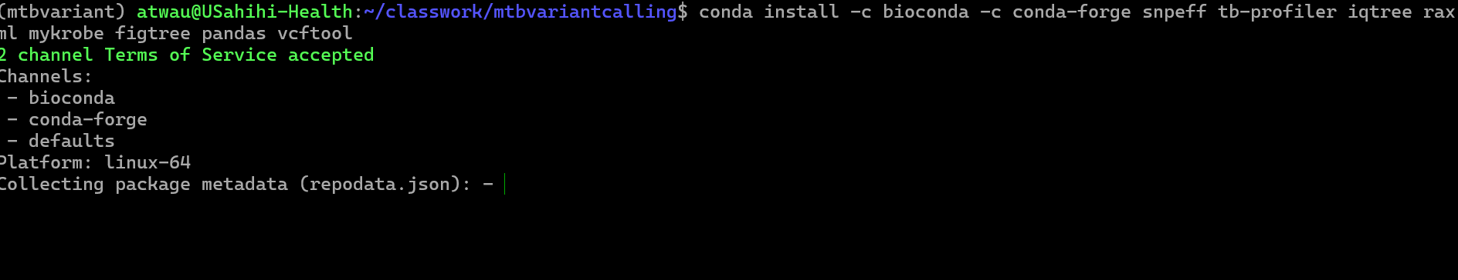
The required software packages for variant annotation, profiling and phylogenetic tree construction were first installed using conda
Annotation with SnpEff followed in 3 steps to predict the functional impact of each variant (e.g., whether it causes a synonymous or non-synonymous change in a protein).
- Building the SnpEff database for the reference genome.
- SnpEff Annotation
- Parsing SnpEff Output for Reporting

Building SnpEff database
- The corresponding GFF (GenBank) file from NCBI, was downloaded for the same assembly of the MTB reference genome

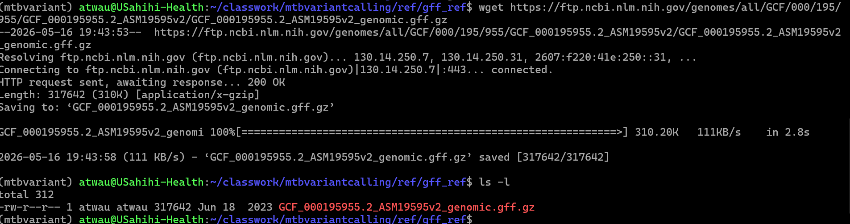
2. The downloaded *.gff.zip ref was then unzipped
3. Construction of SnpEff database
- First snpeff configuration file was created in the project root
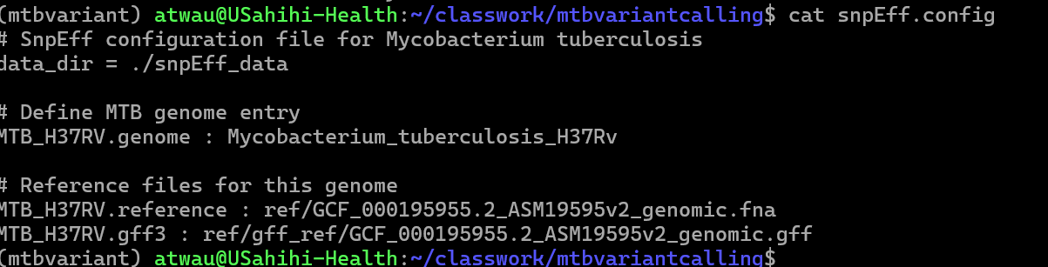
- Building snpeff database
  - Noted snpeff requires its default directory structure inorder for it to perform the variant annotation, i.e. all the ref genome, and gff files must be located within the snpEff_data directory. This necessitated copying *.gff from ref/gff_ref to snpEff_data/MTB_H37RV/ and renaming the file from GCF_000195955.2_ASM19595v2_genomic.gff to simply genes.gff as this is the file which snEff expects.
  - The same was true for ref/GCF_000195955.2_ASM19595v2_genomic.fna which had to be copied to snpEff_data/MTB_H37RV/ and renamed to sequences.fa

The approach of building a custom snpeff database failed. So opted to using prebuilt highly annotated snpeff databases that come with snpeff

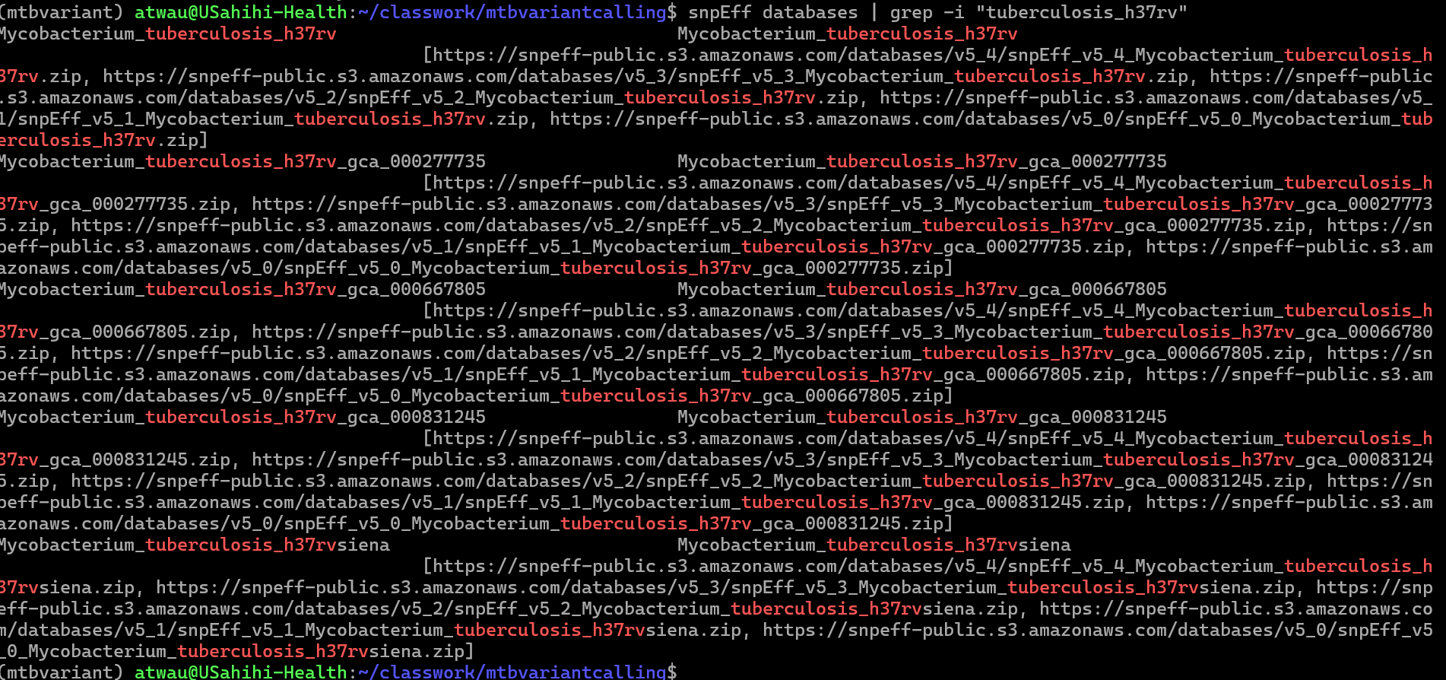
First I searched for prebuilt tuberculosis snpeff databases to choose which to download for my analysis
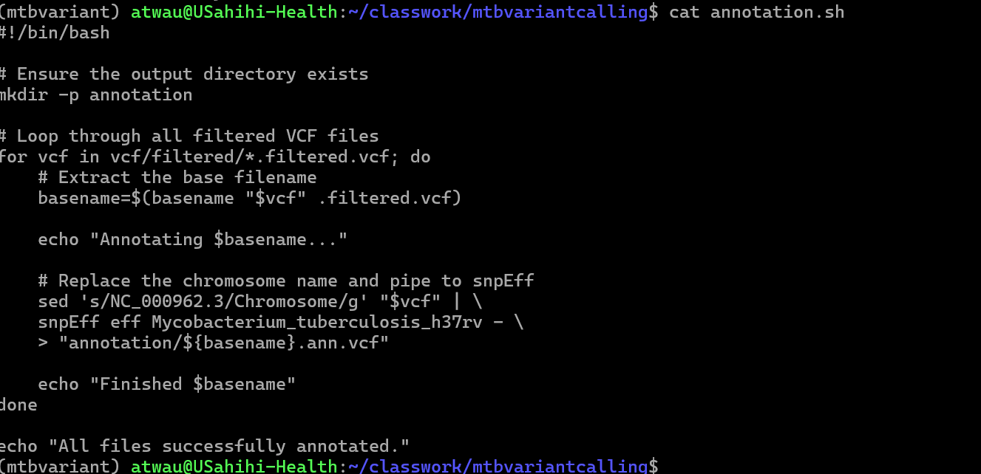
Variant annotation script was then written, and executed on filtered variants created earlier on
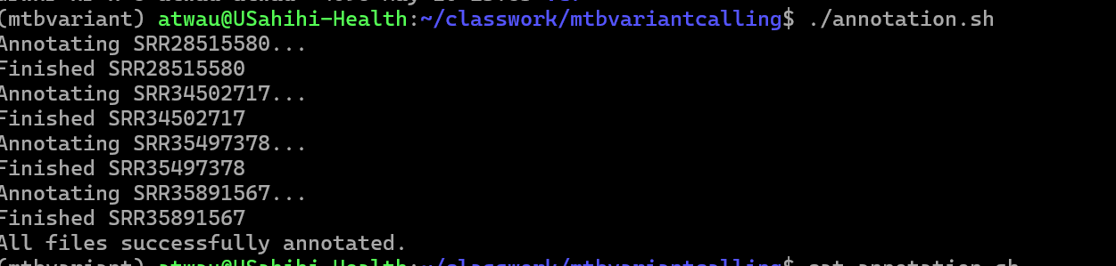

Using SnpSift (which is bundled with SnpEff) to extract specific columns of interest for downstream variant analysis

1. Extract Data into a Tabular Format

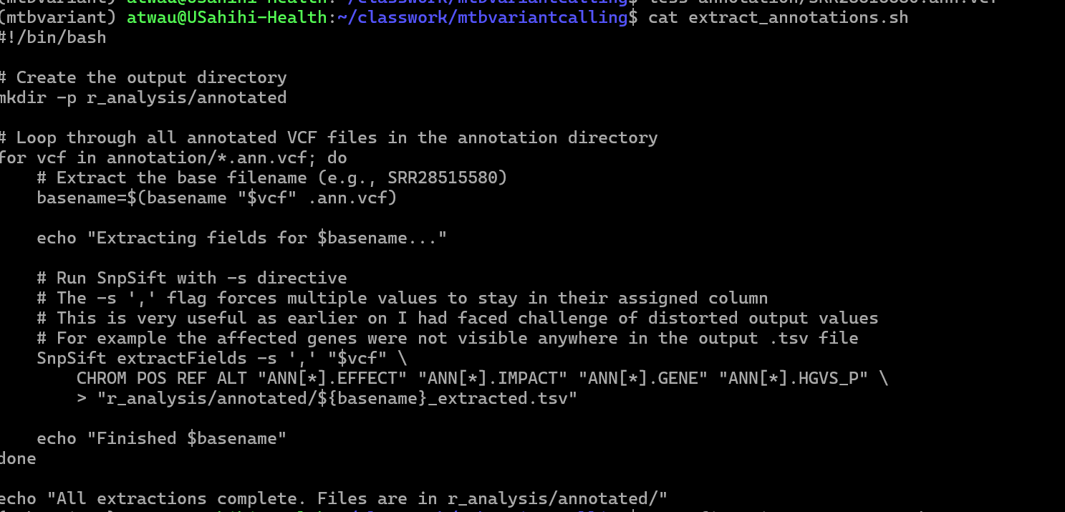
Extracting relevant annotation fields into a flat text file .tsv for analysis in R, using SnpSift (to extract specific columns).

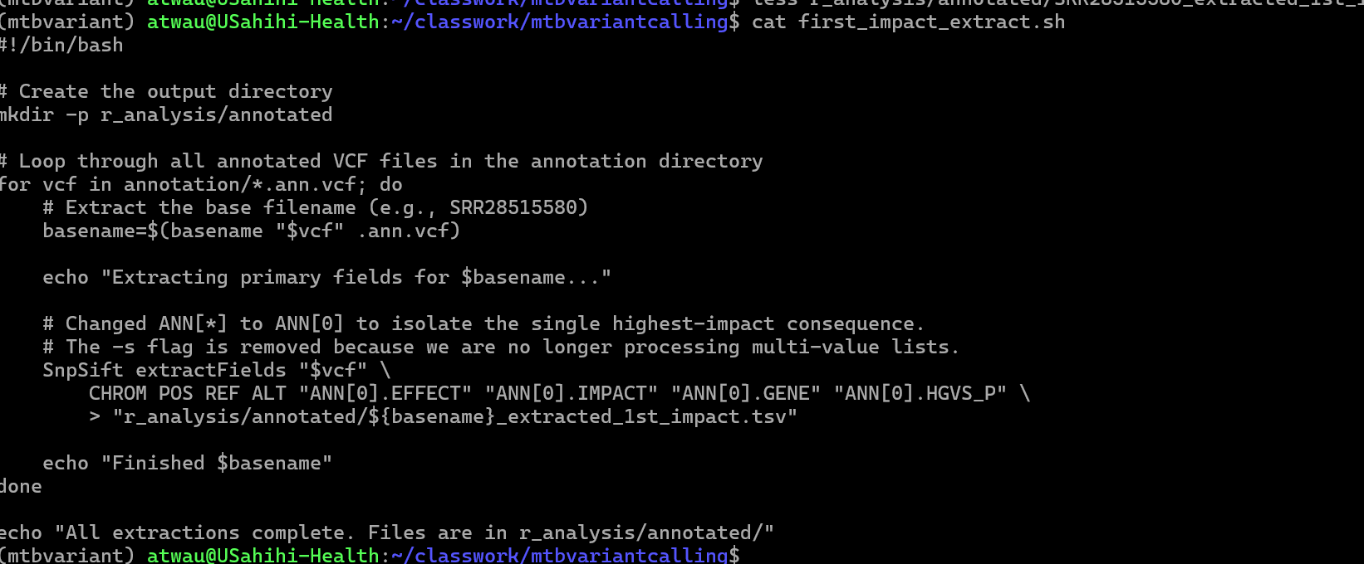
Selecting only the first (primary) annotation impact (by modifying selectors from ANN[*] (which grabs everything) to ANN[0] (which grabs only the first index).
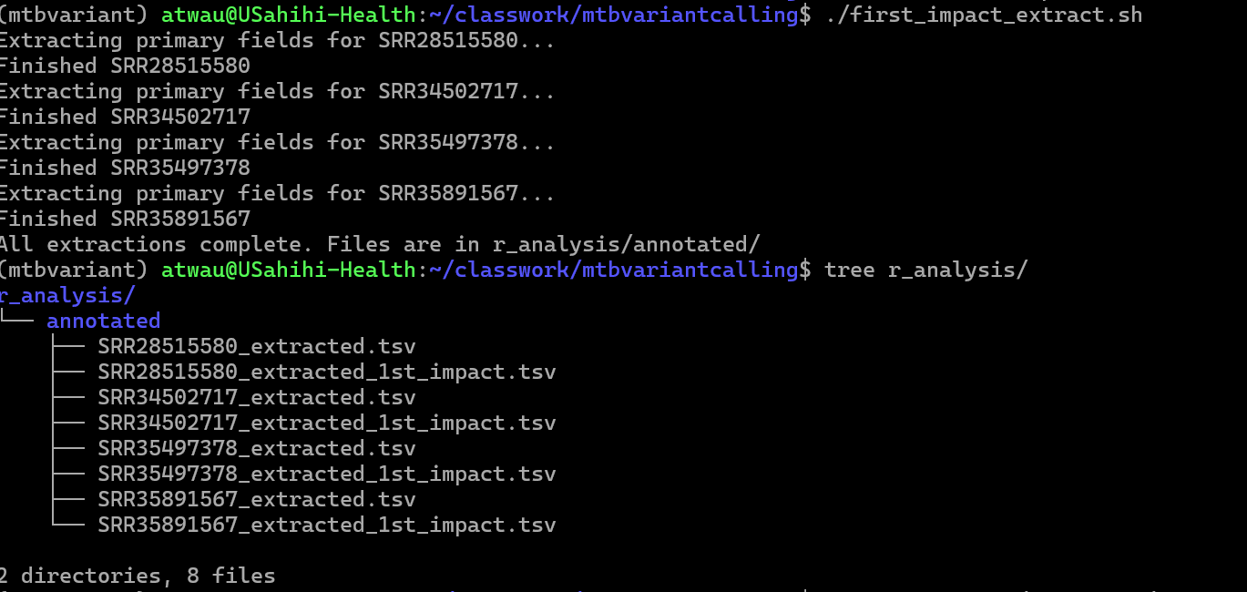

3. Results
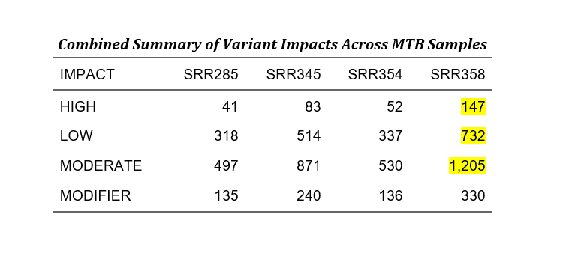

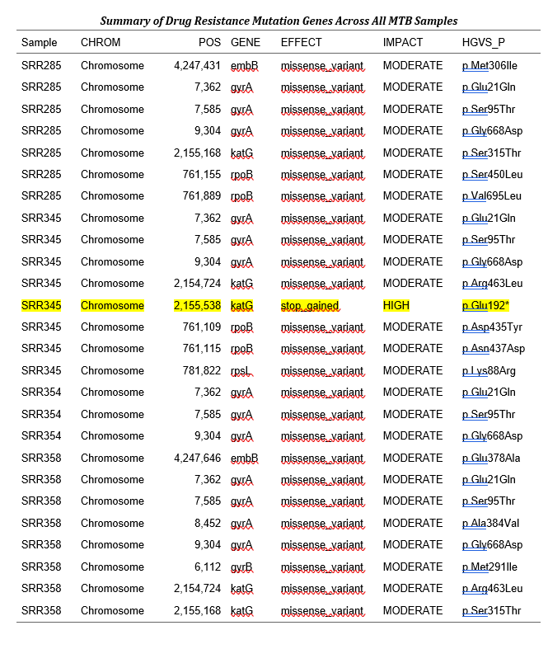
From the analysis, the most clinically relevant isolate was SRR34502717 because it had the highest number of drug resistant gene mutations (i.e. 8) with one being a stop codon i.e. p.Glu192*

Also sample SRR35891567 had 8 top most clinically significant drug resistant gene mutations, however, all had moderate impact on resultant protein gene product
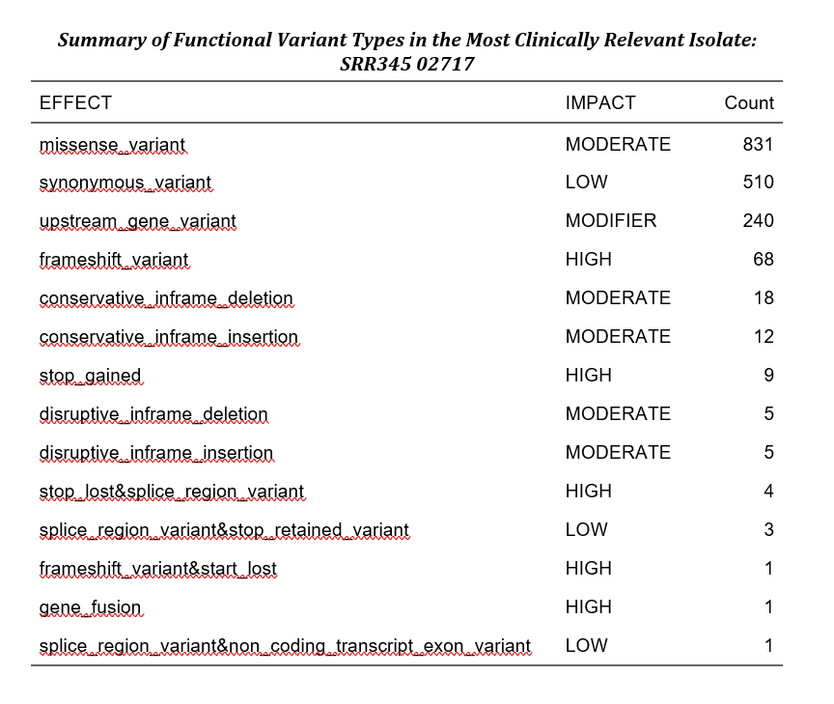

2. Drug Resistance Profiling and Lineage Typing
TB-Profiler was utilized to classify the samples into specific M. tuberculosis lineages and to predict antimicrobial resistance profiles. TB-Profiler was executed using the full profile tag rather than the lineage-only tag. This comprehensive mode cross-references the detected variants against established resistance catalogs (such as the WHO mutation catalog for MTB) to generate detailed drug resistance reports, identify lineage-defining SNPs (e.g., the Coll et al. 2014 SNP barcode), and provide quality control metrics like sequencing depth and missing positions.
Using tb-profiler,
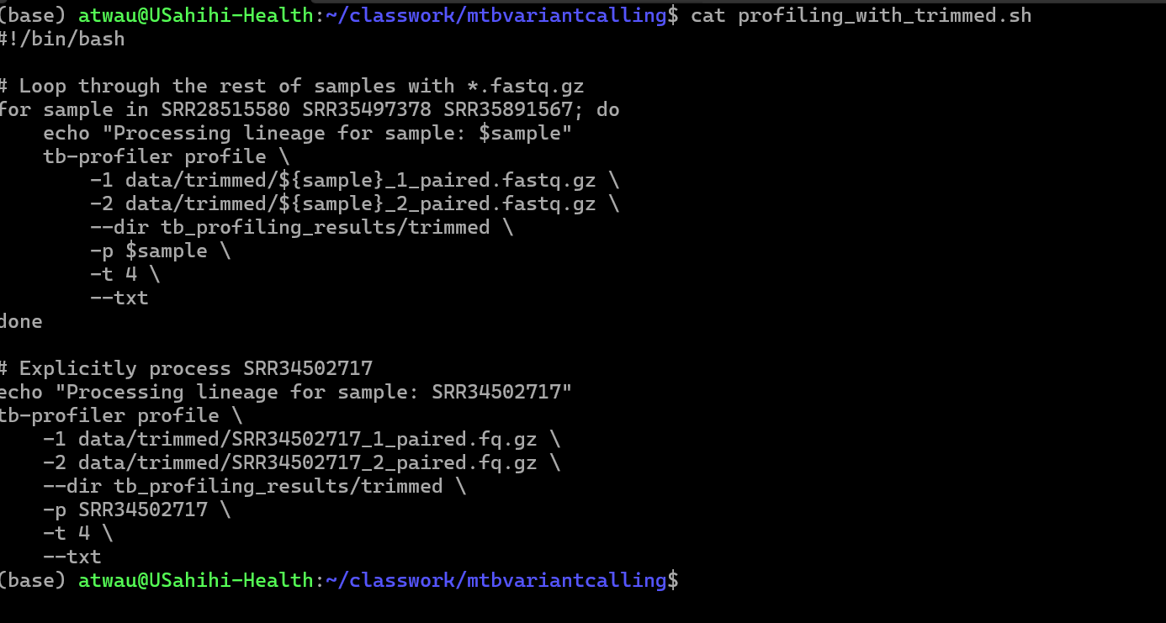
I opted to run tb-profiler with profile tag as opposed to lineage tag alone to obtain other useful information like drug resistance reports. Lineage-only mode would not produce drug resistance reports, detailed variant lists, or QC metrics like depth, missing positions, etc. It only outputs the predicted lineage (e.g., Lineage 4.3, East-African-Indian, etc.)
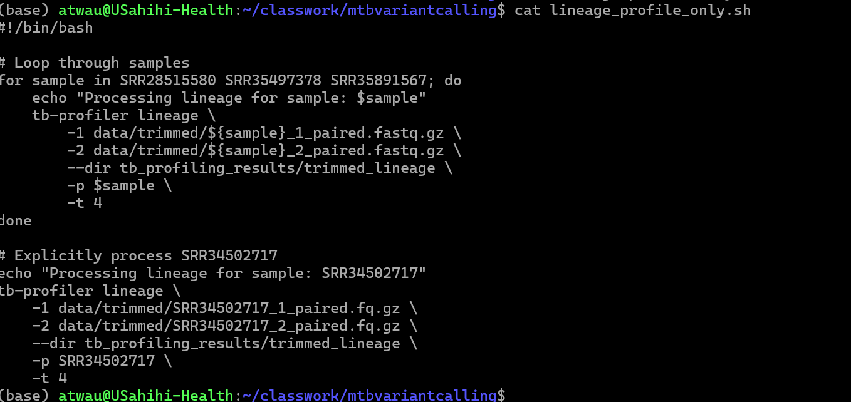
Tb-profiler with lineage tag alone
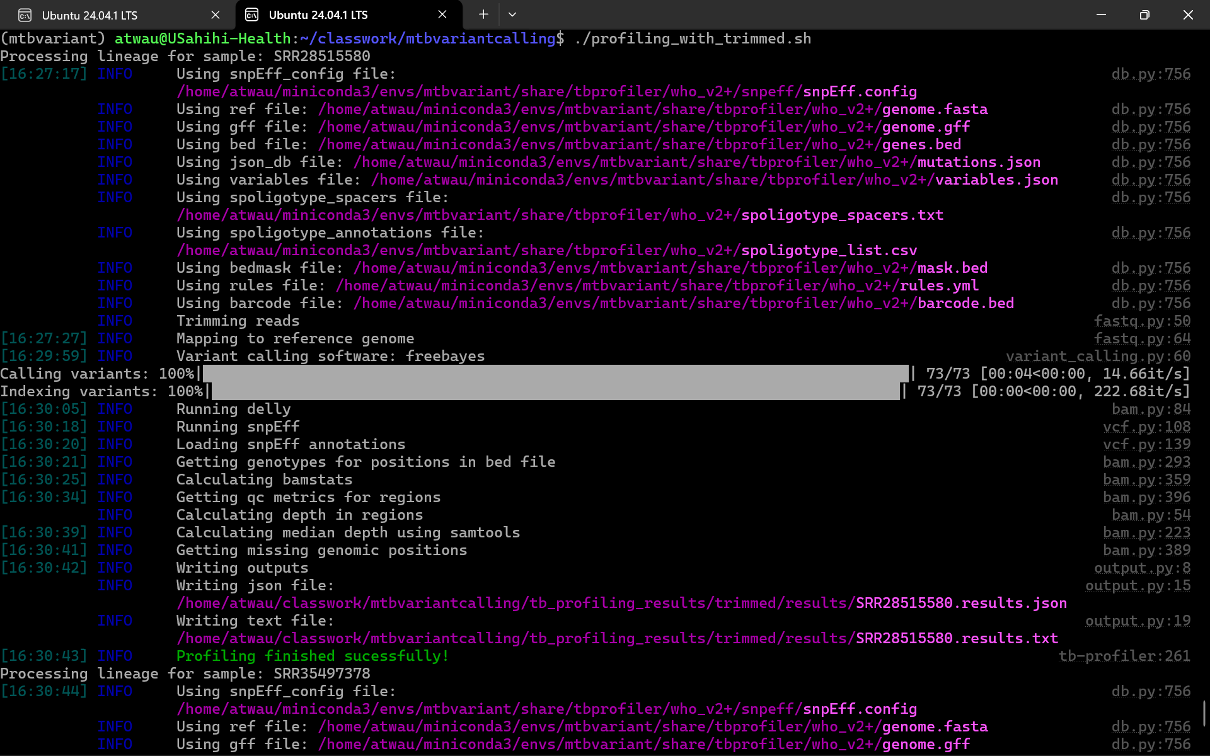
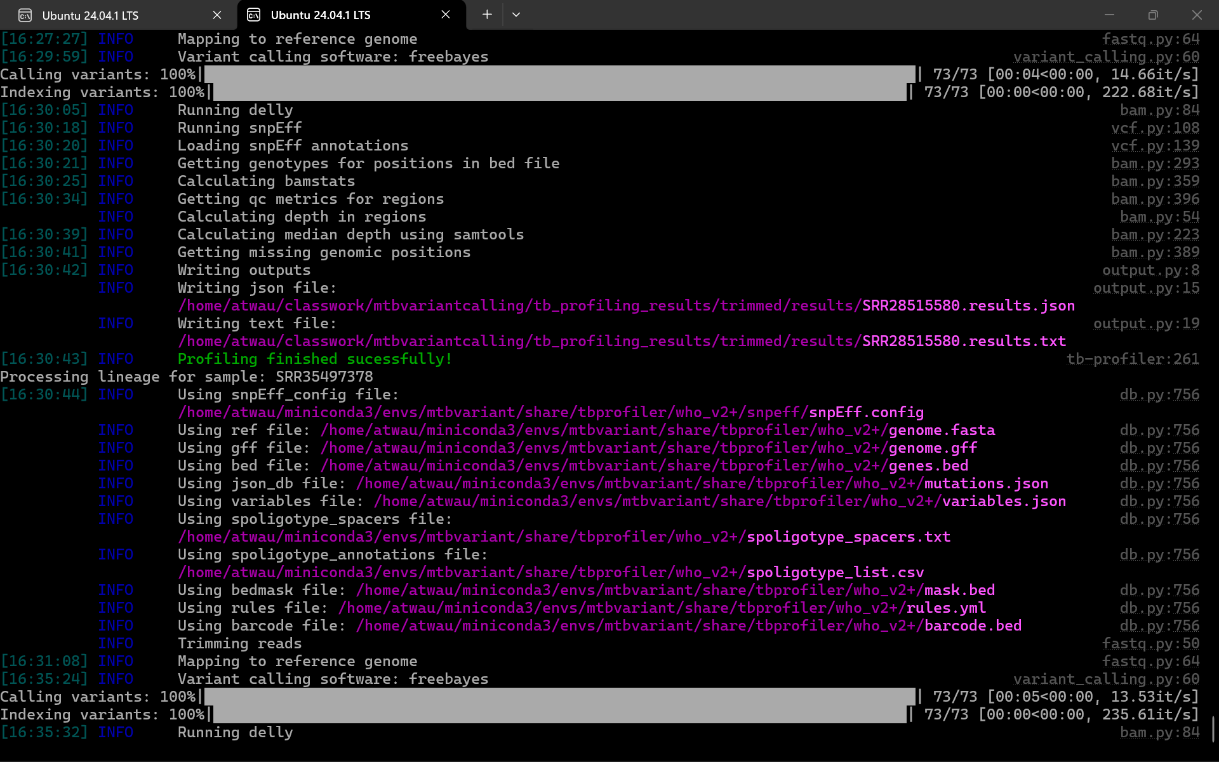
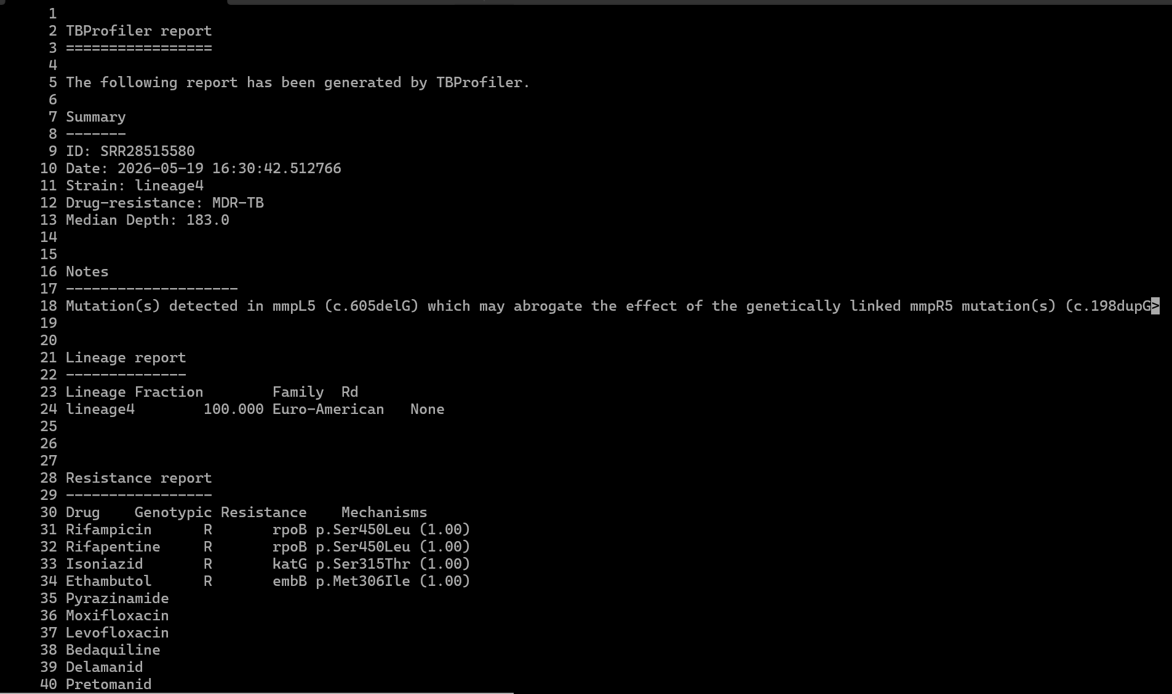
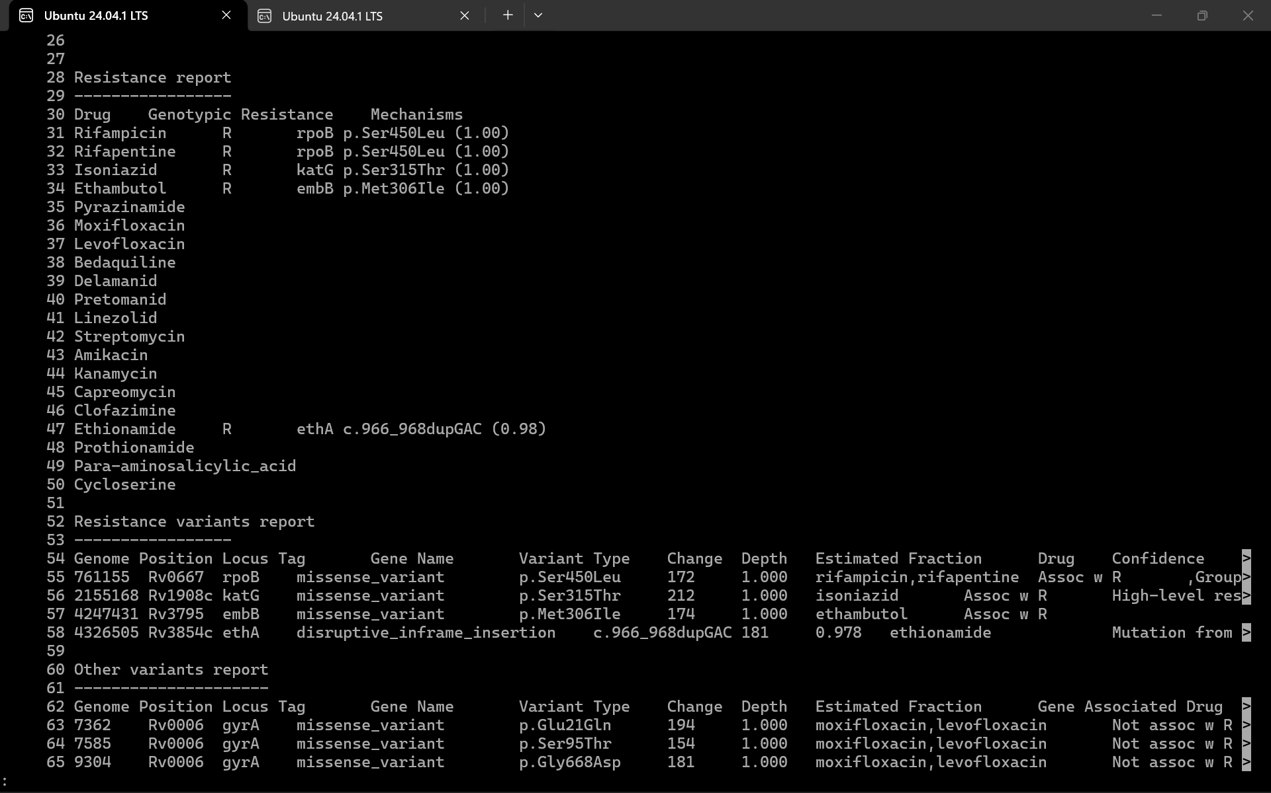
Sample SRR28515580
Lineage: Lineage 4 (Euro-American)
Resistance Profile: MDR-TB (Multidrug-resistant TB)
Detected Resistances:
- Rifampicin (rpoB p.Ser450Leu)
- Rifapentine (rpoB p.Ser450Leu)
- Isoniazid (katG p.Ser315Thr)
- Ethambutol (embB p.Met306Ile)
- Ethionamide (ethA c.966_968dupGAC)

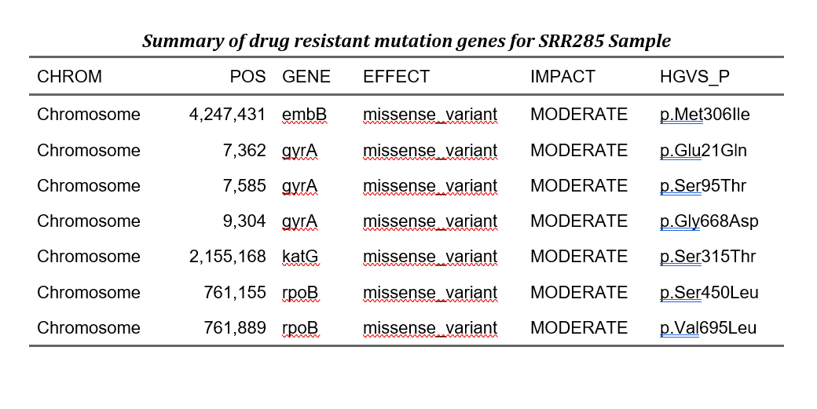
SAMPLE 2
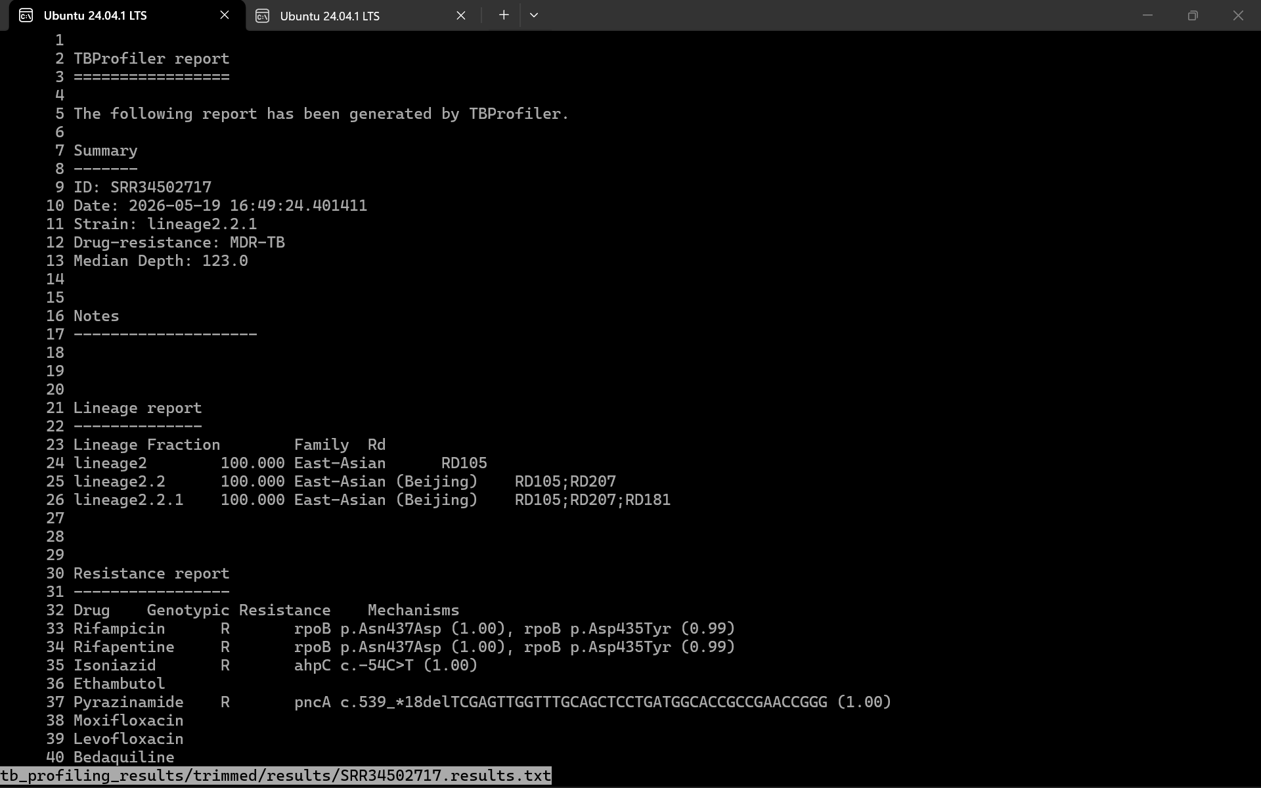
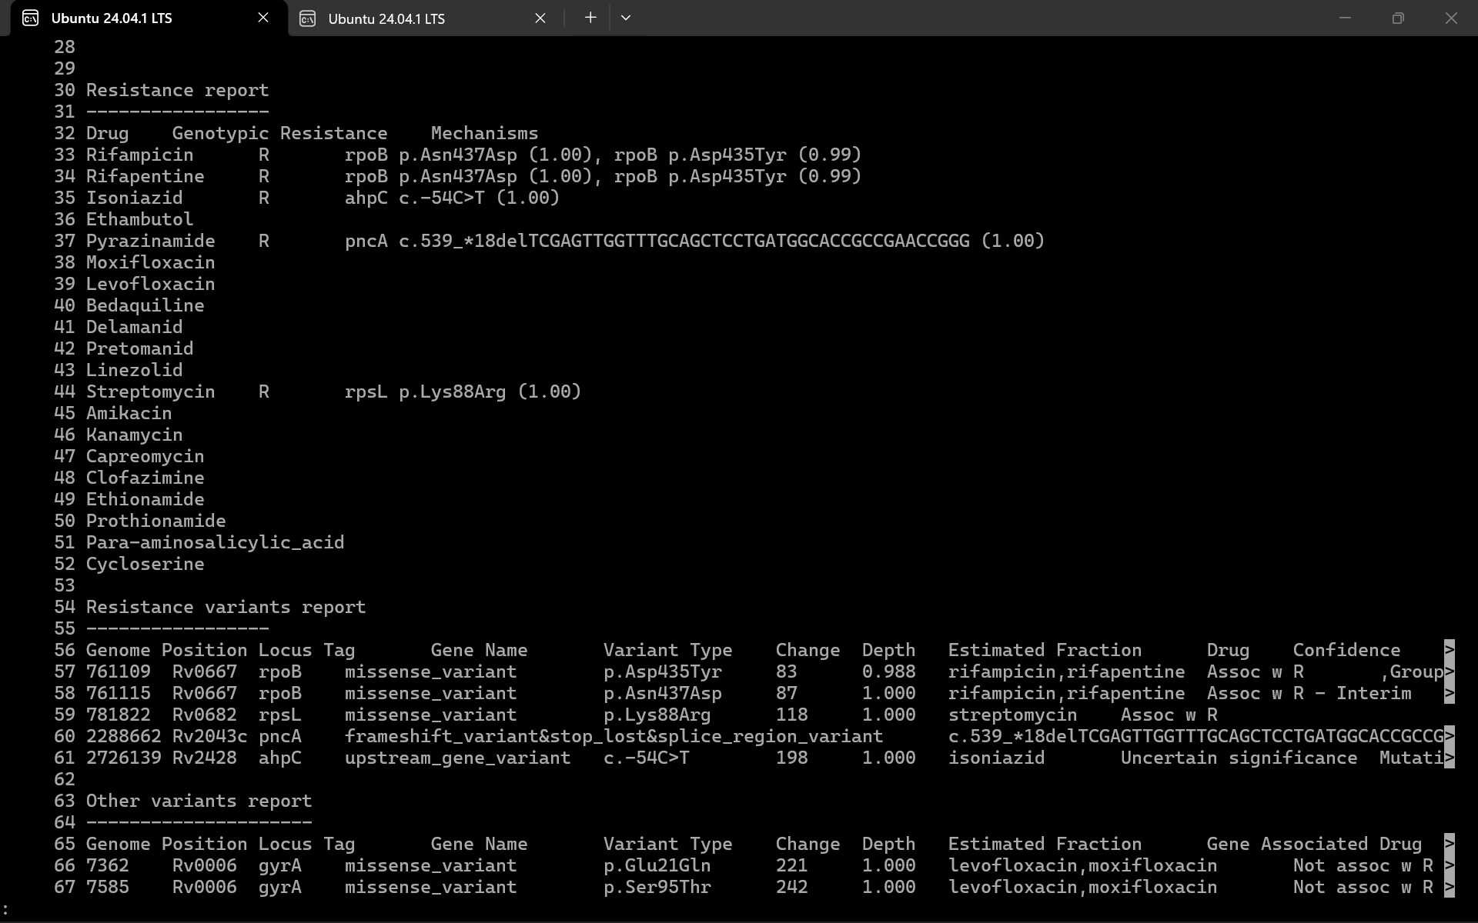
SRR34502717
Lineage: Lineage 2.2.1 (East-Asian / Beijing)
Resistance Profile: MDR-TB
Detected Resistances:
- Rifampicin (rpoB p.Asn437Asp, rpoB p.Asp435Tyr)
- Rifapentine (rpoB p.Asn437Asp, rpoB p.Asp435Tyr)
- Isoniazid (ahpC c.-54C>T)
- Pyrazinamide (pncA deletion)

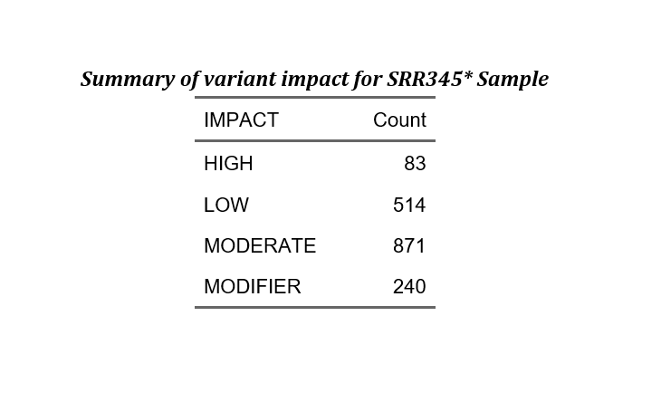
SAMPLE 3
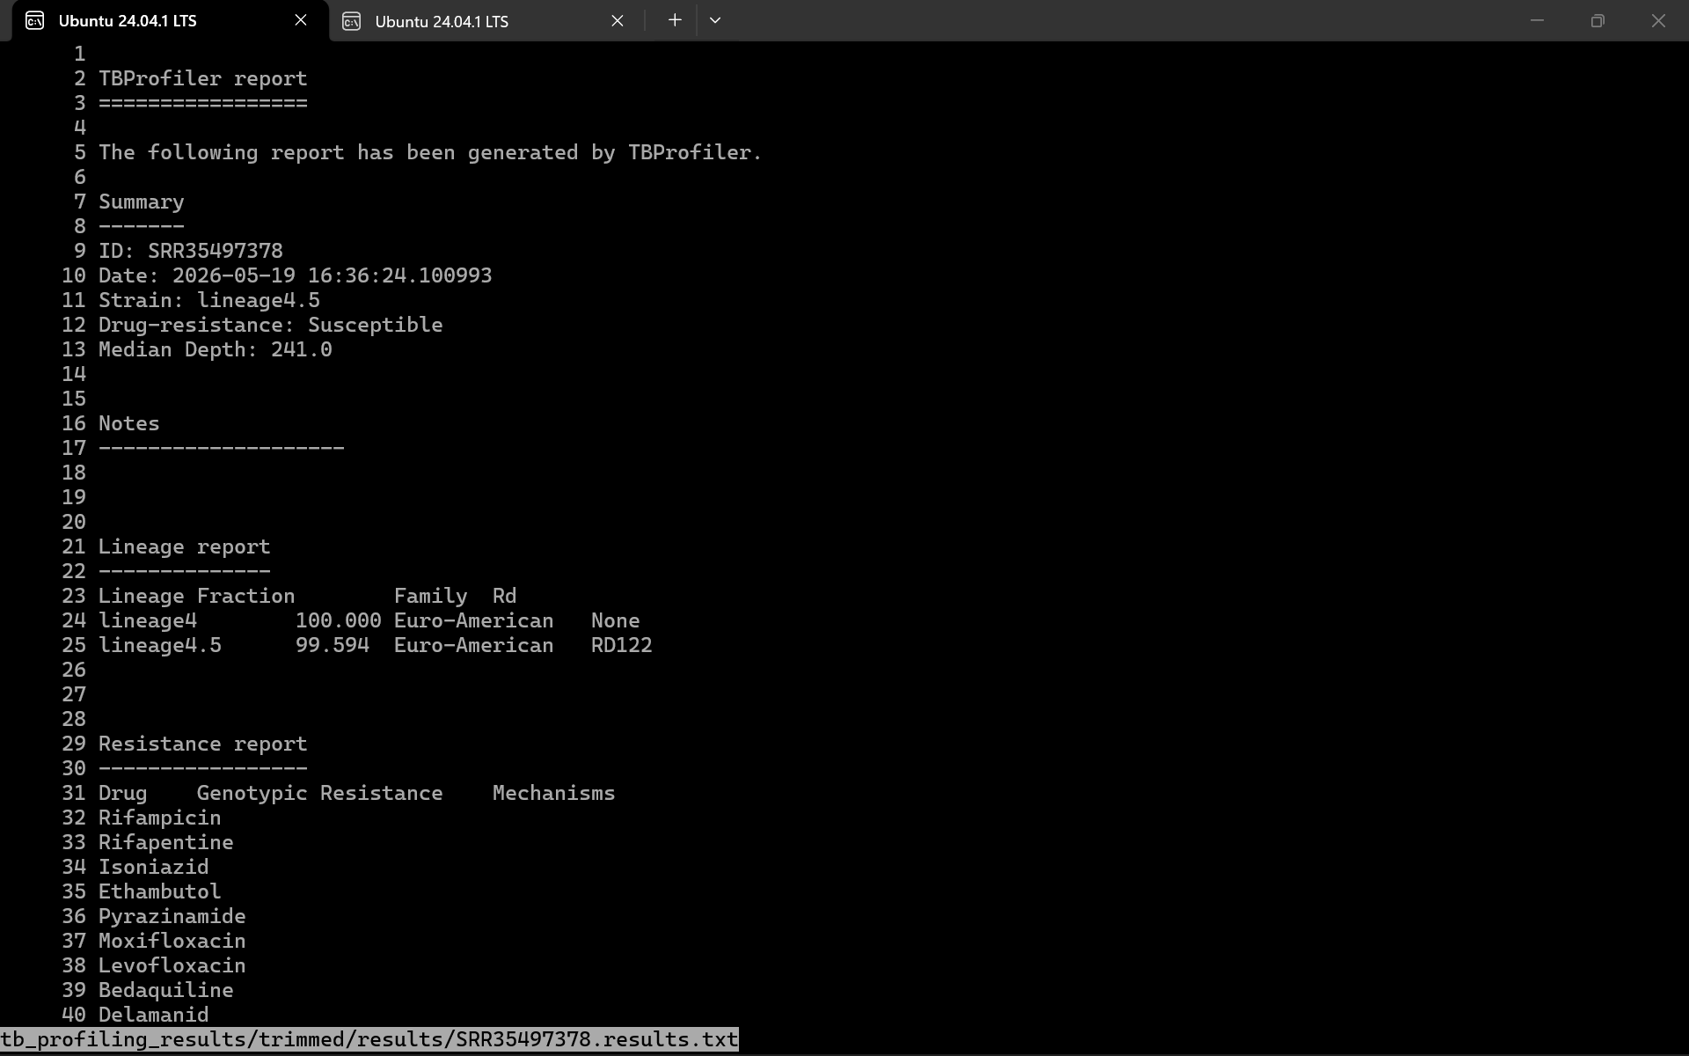
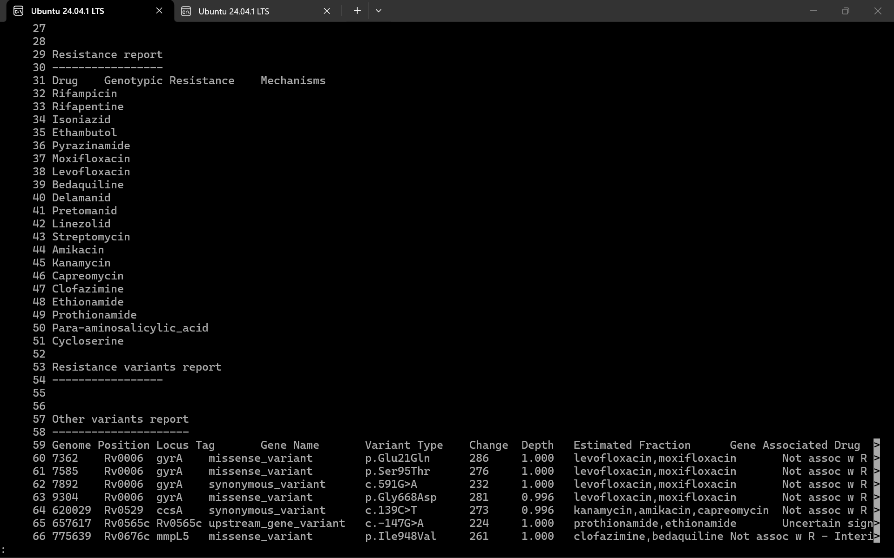
SRR35497378
Lineage: Lineage 4.5 (Euro-American)
Resistance Profile: Susceptible
Detected Resistances: None. The profile indicates susceptibility to all tested anti-TB drugs.

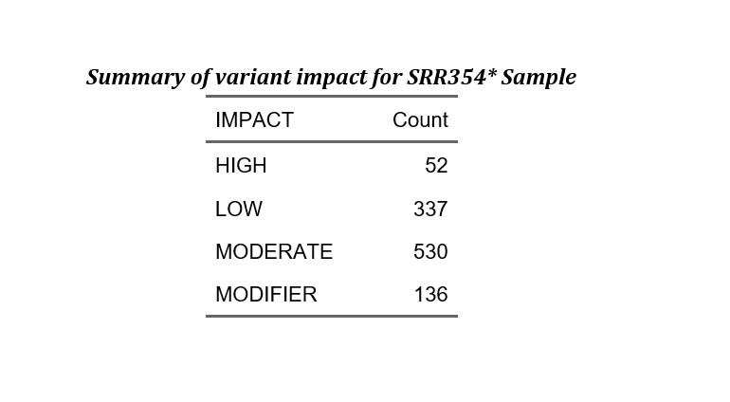
SAMPLE 4
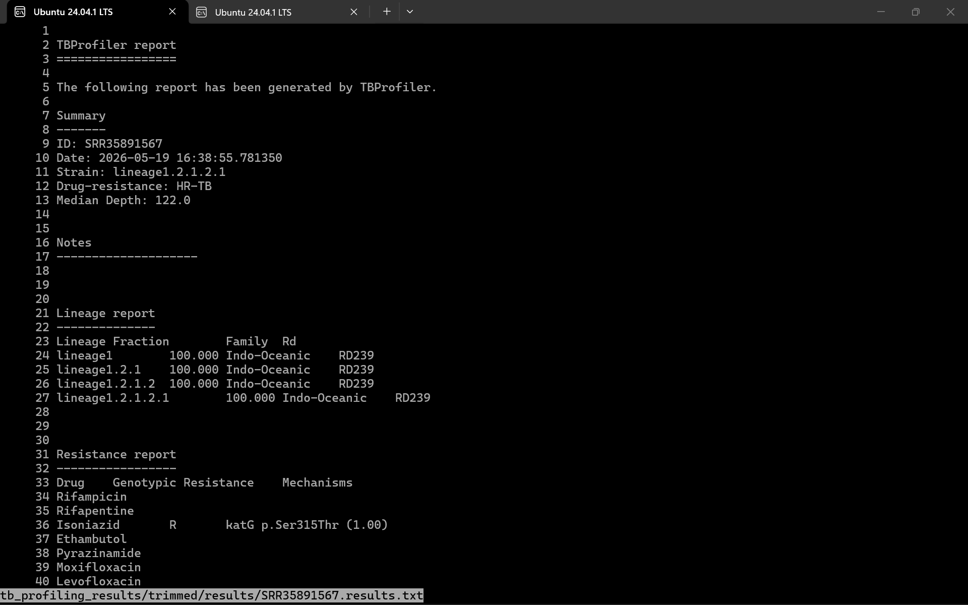
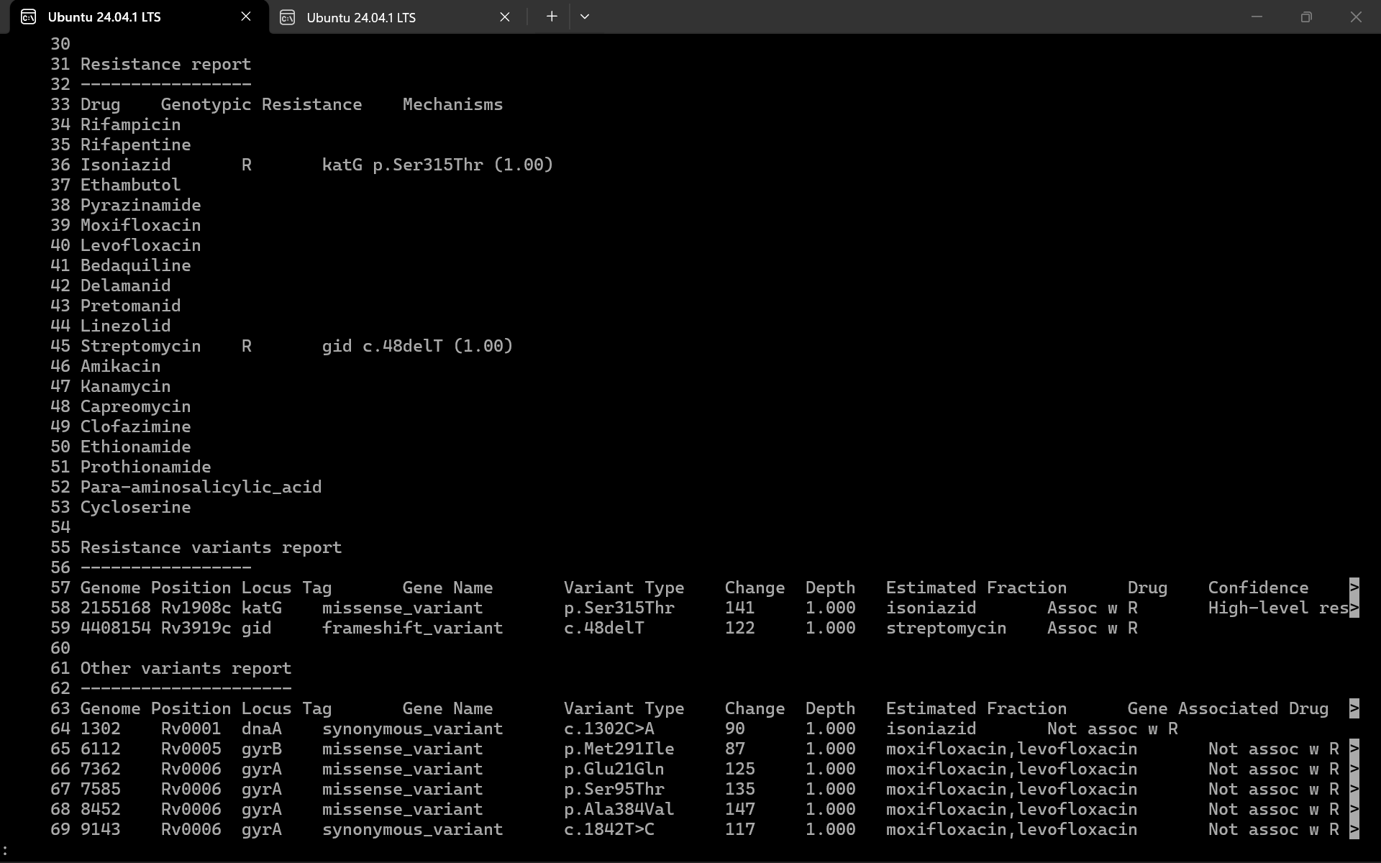
SRR35891567
Lineage: Lineage 1.2.1.2.1 (Indo-Oceanic)
Resistance Profile: HR-TB (Isoniazid-resistant TB)
Detected Resistances:
- Isoniazid (katG p.Ser315Thr)
- Streptomycin (gid c.48delT)

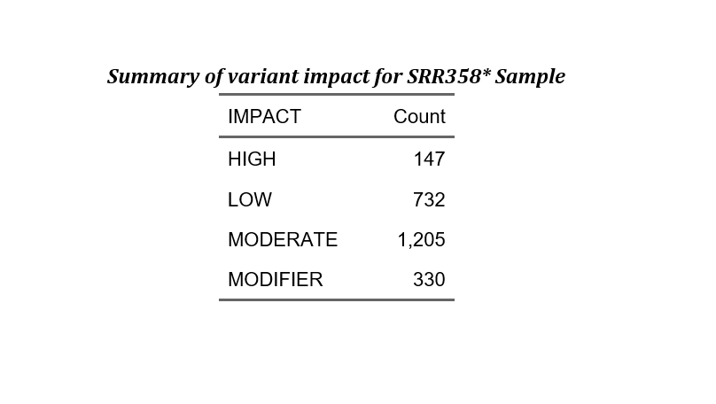

.
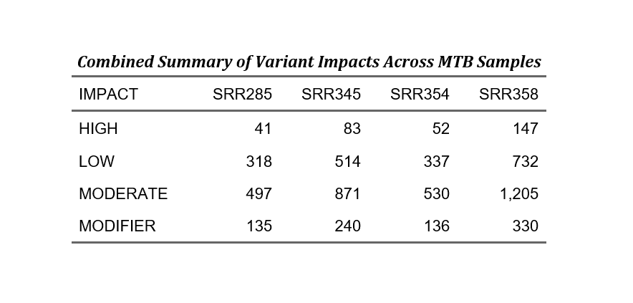

Phylogenetic tree construction
- First iqtree package for phylogenetic tree construction was installed
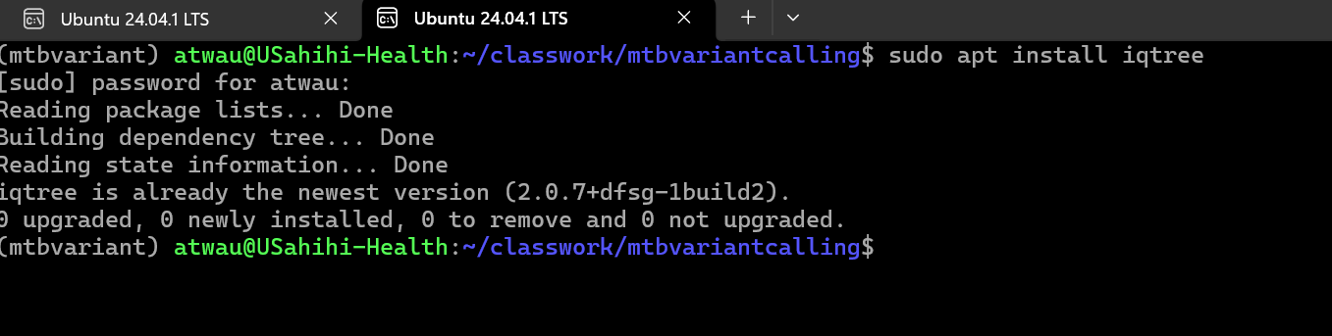
Iqtree installation
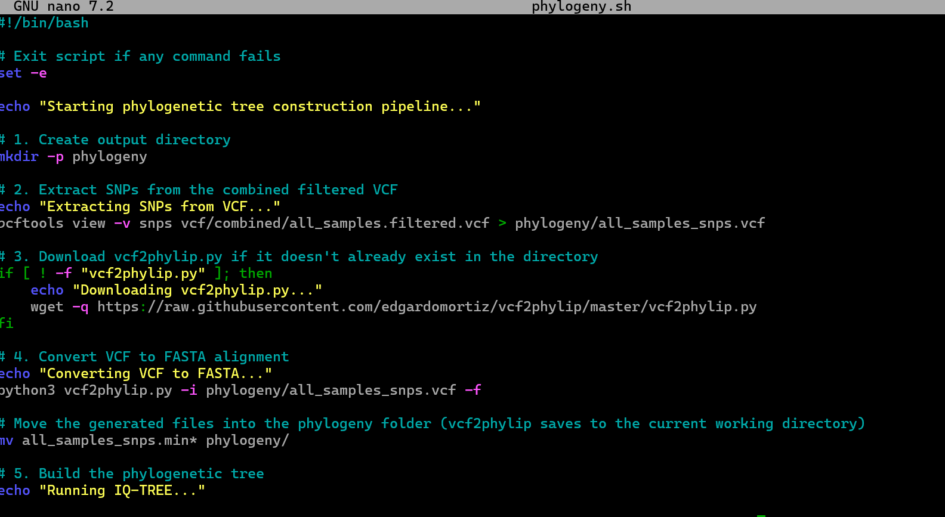
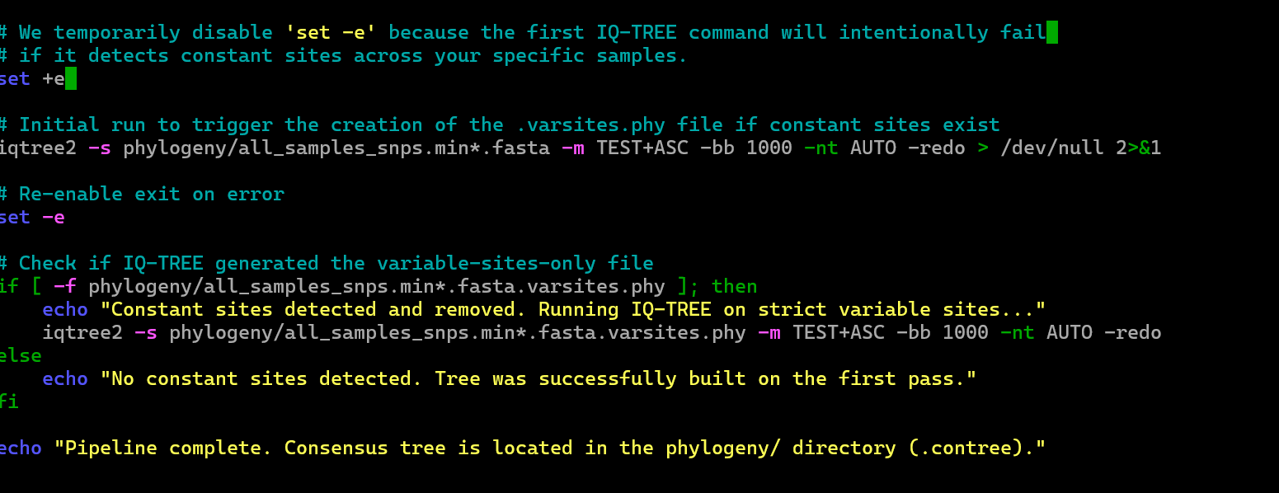
Bash script for phylogenetic tree construction was then written, but this involved trying individual codes, the ones which worked were then compiled into single script
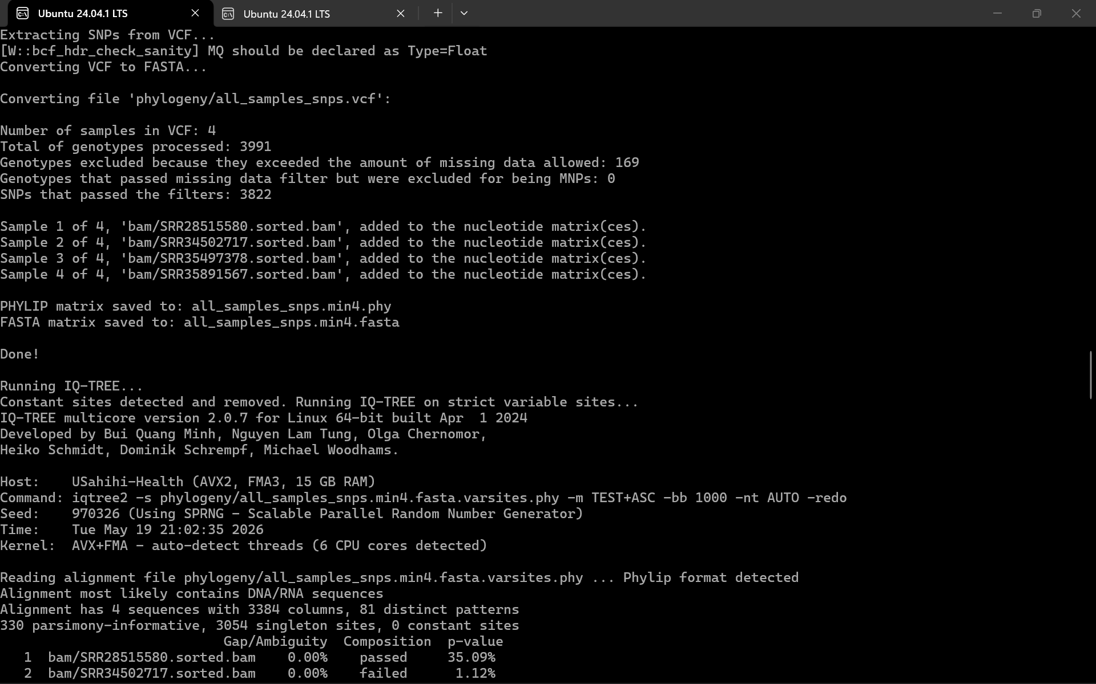
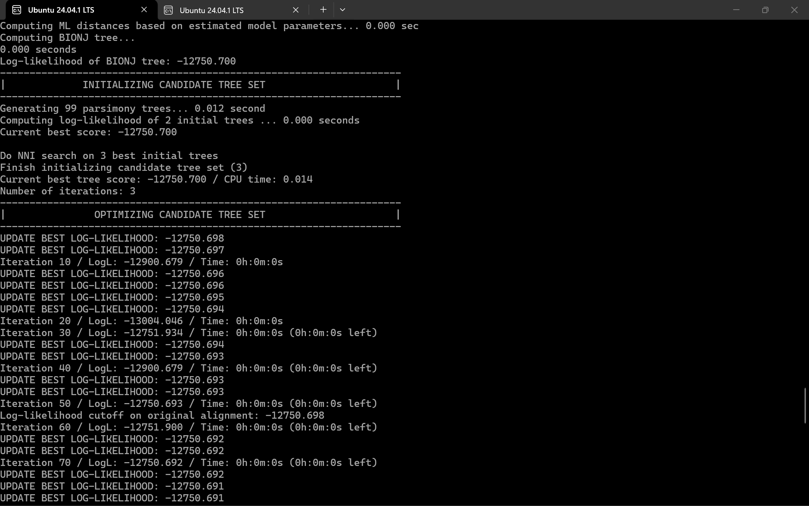
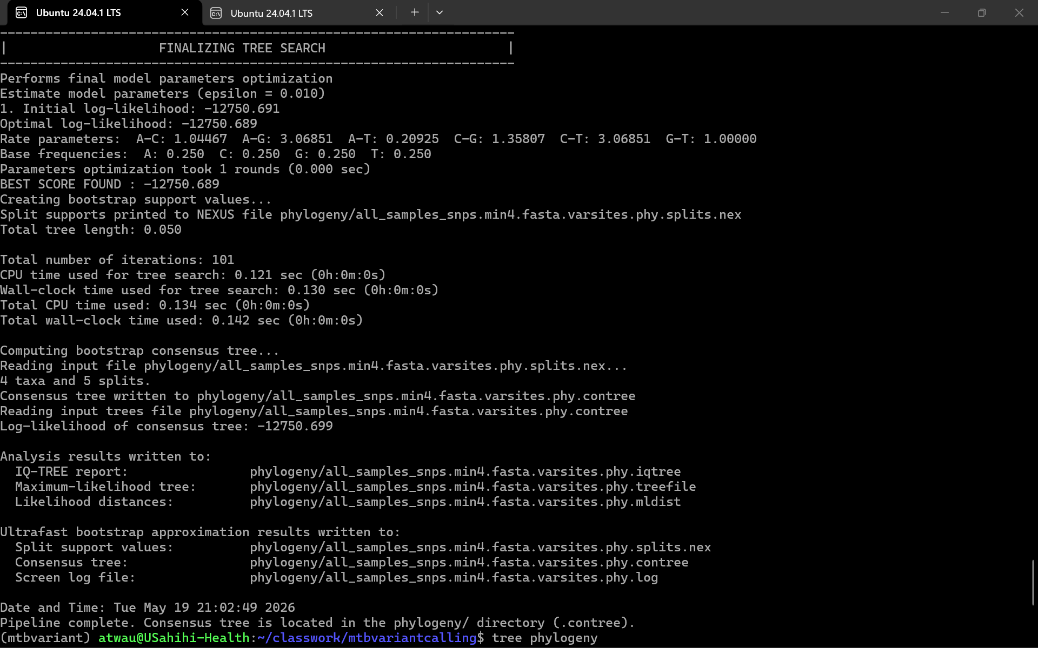
Script was then run to construct the phylogenetic tree
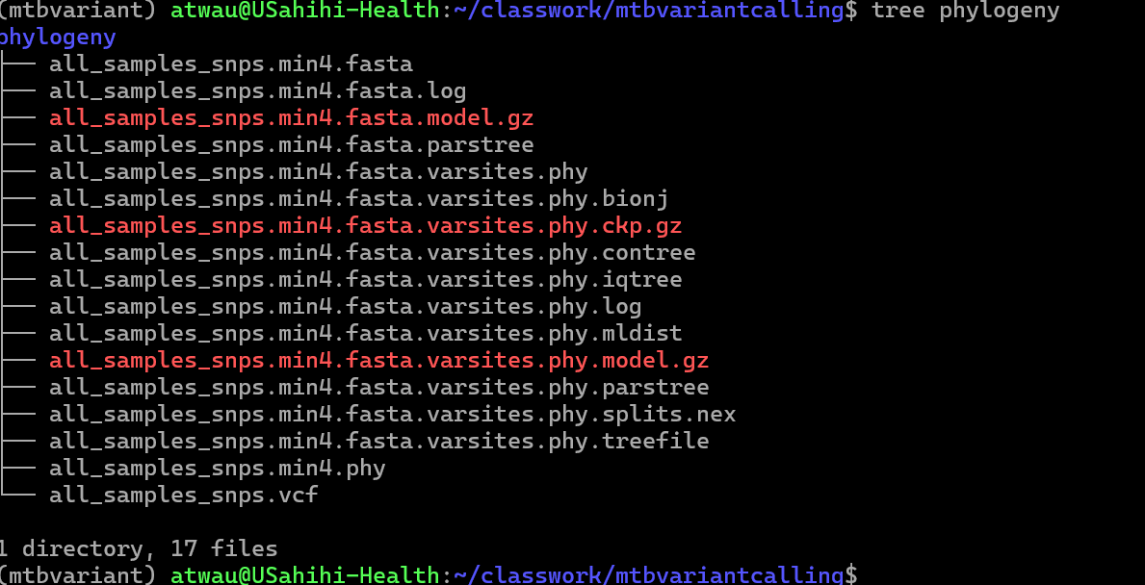
Phylogenetic tree output
Tthe phylogenetic tree was then visualized using figtree desktop application
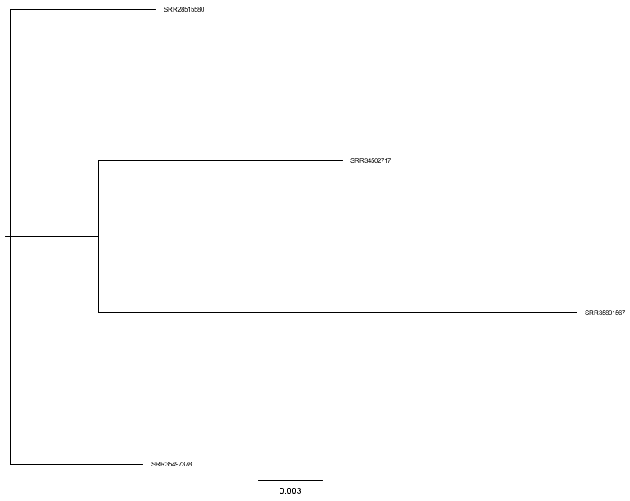
The phylogenetic tree reveals three distinct evolutionary trajectories among the Mycobacterium tuberculosis samples, aligning with their recognized global lineages. Samples SRR35497378 and SRR28515580 share a recent common ancestor, forming a tightly clustered Euro-American (Lineage 4) clade supported by maximum (100%) bootstrap confidence. Diverging significantly from this group is sample SRR34502717, which occupies a long, separate branch representative of the distinct East-Asian/Beijing (Lineage 2) evolutionary path. Finally, sample SRR35891567 represents the most genetically distinct isolate in this dataset, branching off entirely on its own to reflect its ancient Indo-Oceanic (Lineage 1) origins, highlighting the broad genetic diversity captured across these four clinical samples.

4. Discussion
The comparative genomic analysis of the four M. tuberculosis isolates highlighted the intersection of lineage diversity and antimicrobial resistance. The isolates span three major global lineages: Lineage 1 (Indo-Oceanic), Lineage 2 (East-Asian/Beijing), and Lineage 4 (Euro-American). Lineage 4 is known to be the most globally widespread, which is consistent with the clustering of SRR35497378 and SRR28515580. Lineage 2, the Beijing sublineage (SRR34502717), is frequently associated with high transmission rates and a strong propensity for acquiring multidrug resistance. Lineage 1 (SRR35891567) is considered an evolutionarily ancient lineage, primarily restricted to regions around the Indian Ocean.
The drug resistance profiles correlate strongly with the identified mutations. Sample SRR28515580 (MDR-TB) harbors the classic rpoB p.Ser450Leu mutation, which is the most common mechanism conferring high-level resistance to Rifampicin by altering the drug-binding site on the RNA polymerase beta-subunit. It also contains the katG p.Ser315Thr mutation, a hallmark of high-level Isoniazid resistance resulting from the diminished activation of the prodrug. Interestingly, this isolate also features a frameshift deletion in mmpL5 (c.605delG). The MmpS5-MmpL5 efflux pump system is implicated in resistance to bedaquiline and clofazimine; mutations in mmpL5 can abrogate the efflux function, potentially restoring susceptibility or counteracting mutations in the mmpR5 repressor
Sample SRR34502717 (MDR-TB, Beijing lineage) exhibited a different resistance mechanism profile. It lacked the common katG mutation but possesses a promoter mutation in ahpC (c.-54C>T), which is a compensatory mutation often associated with Isoniazid resistance. Furthermore, it harbored a deletion in the pncA gene. The pncA gene encodes pyrazinamidase, which converts the prodrug pyrazinamide into its active form; deletions or loss-of-function mutations (such as the p.Glu192* stop codon noted in the SnpEff results) in this gene are the primary drivers of pyrazinamide resistance
Sample SRR35891567 (HR-TB) demonstrates Isoniazid resistance via the katG p.Ser315Thr mutation and low-level Streptomycin resistance through a frameshift mutation in the gid gene (c.48delT). Mutations in gidB (encoding a conserved 16S rRNA methyltransferase) are well-documented causes of low-level streptomycin resistance and are sometimes lineage-specific polymorphisms
The phylogenetic tree supported the epidemiological and evolutionary independence of these isolates. The tight clustering of the two Lineage 4 isolates suggests a closer genetic relationship, though one is MDR-TB and the other is fully susceptible, indicating that the resistance in SRR28515580 was likely acquired independently after divergence. The long branch lengths separating the Lineage 1, Lineage 2, and Lineage 4 clades refute any direct epidemiological link or recent transmission chain between these specific patients, instead reflecting the broad, independent global circulation of these distinct strains.

